Komponentliste
Nedenfor er liste for komponenter som ble kjøpt inn til prosjektet
Beskrivelse | Bilde
1-CHANNEL 5-AMP RELAY BOARDWITH ANDROID BLUETOOTH INTERFACE  Varenummer: NCDR15PLZBT  Modellnummer: R15PL_ZBT  Pris: 115 USD  Leverandør: Relay Pros, LLC  Link: https://relaypros.com/Relay/Device/R15PL_ZBT | 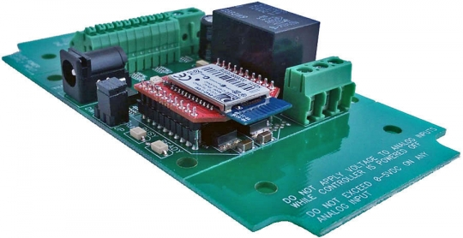
NCD ZBT-EXT BLUETOOTH EXTENTION  Varenummer: NCDZBTEXT  Pris: 20 USD  Leverandør: Relay Pros, LLC  Link: https://relaypros.com/Relay/Device/R15PL_ZBT | 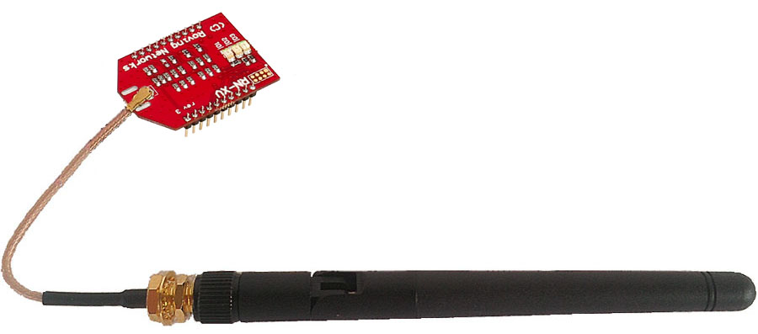
ZIGMO: CONFIGURATION KIT  Varenummer: NCDZIGMO  Pris: 39 USD  Leverandør: Relay Pros, LLC  Link: https://relaypros.com/Relay/Device/R15PL_ZBT | 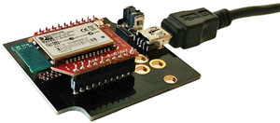
RP 12V COMPUTER GRADE 5-BLADEINTERNATIONAL POWER SUPPLY  Varenummer: RPIPWR12  Pris: 36 USD  Leverandør: Relay Pros, LLC  Link: https://relaypros.com/Relay/Device/R15PL_ZBT | 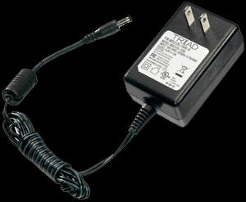
2 Channel BluetoothRelay Module  Varenummer: BTRL002  Pris: 49,95 USD  Leverandør: Numato Systems Pvt Ltd  Link: https://numato.com/product/2-channel-bluetooth-relay-module | 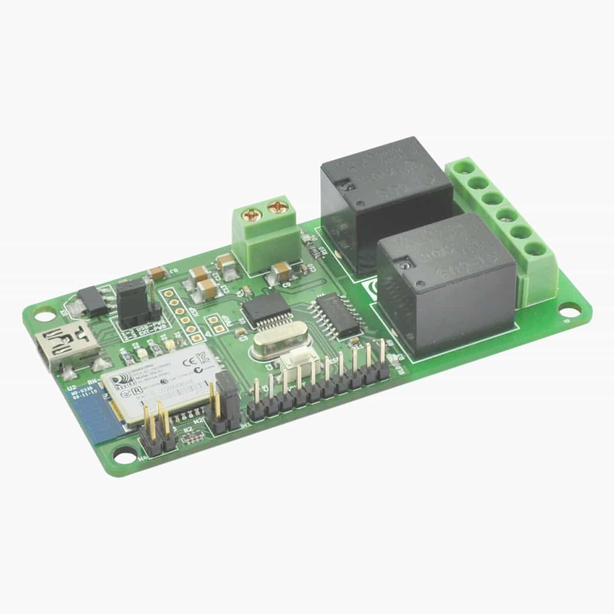
Bluetooth-modul for Arduino (HC-05)  Artikkelnr: 87061, Modellnr: VMA302  Pris: 199,90 NOK  Leverandør: Kjell & Company  Link: https://www.kjell.com/no/produkter/elektro-og-verktoy/arduino/moduler/bluetooth-modul-for-arduino-p87061 | 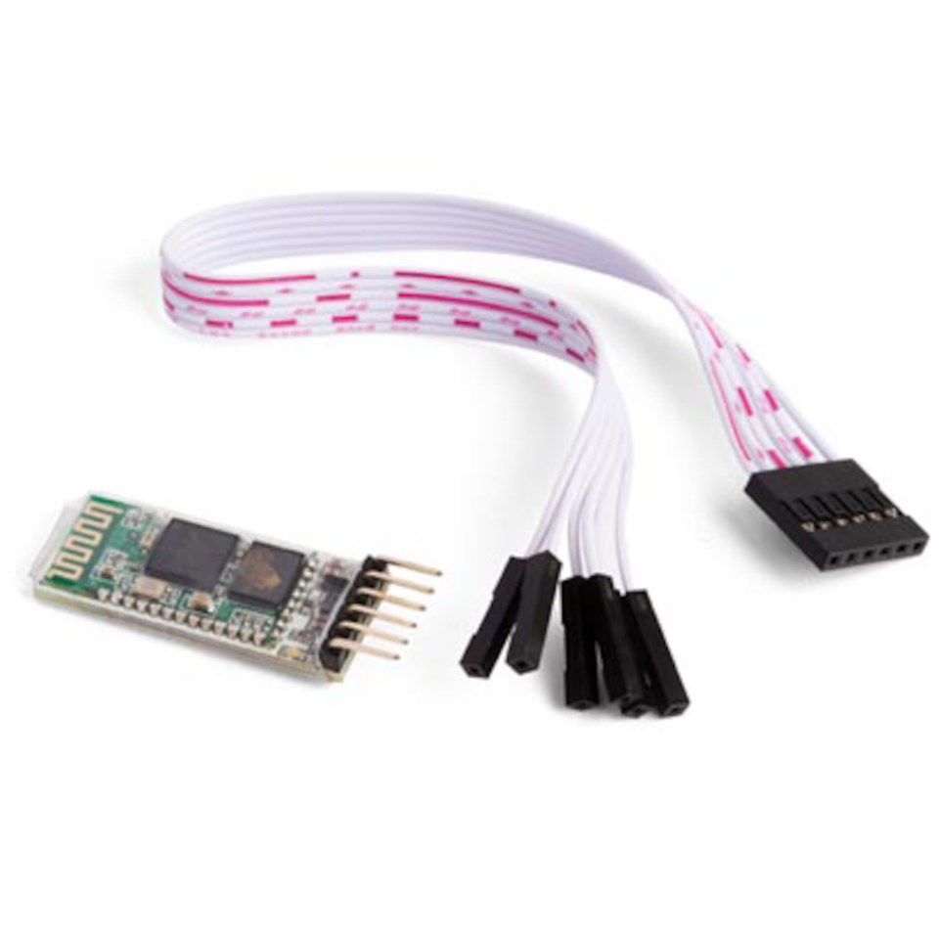
Koblingsboks HellermannTyton DK  Artikkelnr: Artikkel nr: 1270304  Pris:  Leverandør: Ahlsell  Link: https://www.ahlsell.no/33/elektro/gr.-11---25-installasjonsmateriell/12---ror-tak--og-veggbokser-koblingsmateriell/bokser-fittings/boks--kapsling-for-innfelt-montering-i-veggtak/1270304/ | 